ParkFindr

Luke Martin N9452362

Vanessa Gutierez N9890394

Myles Robinson N9891838

Queensland University of Technology

CAB230 – Web Computing

Preferred browser: Google Chrome

2a. Accessing the home screen

Input:





Output:

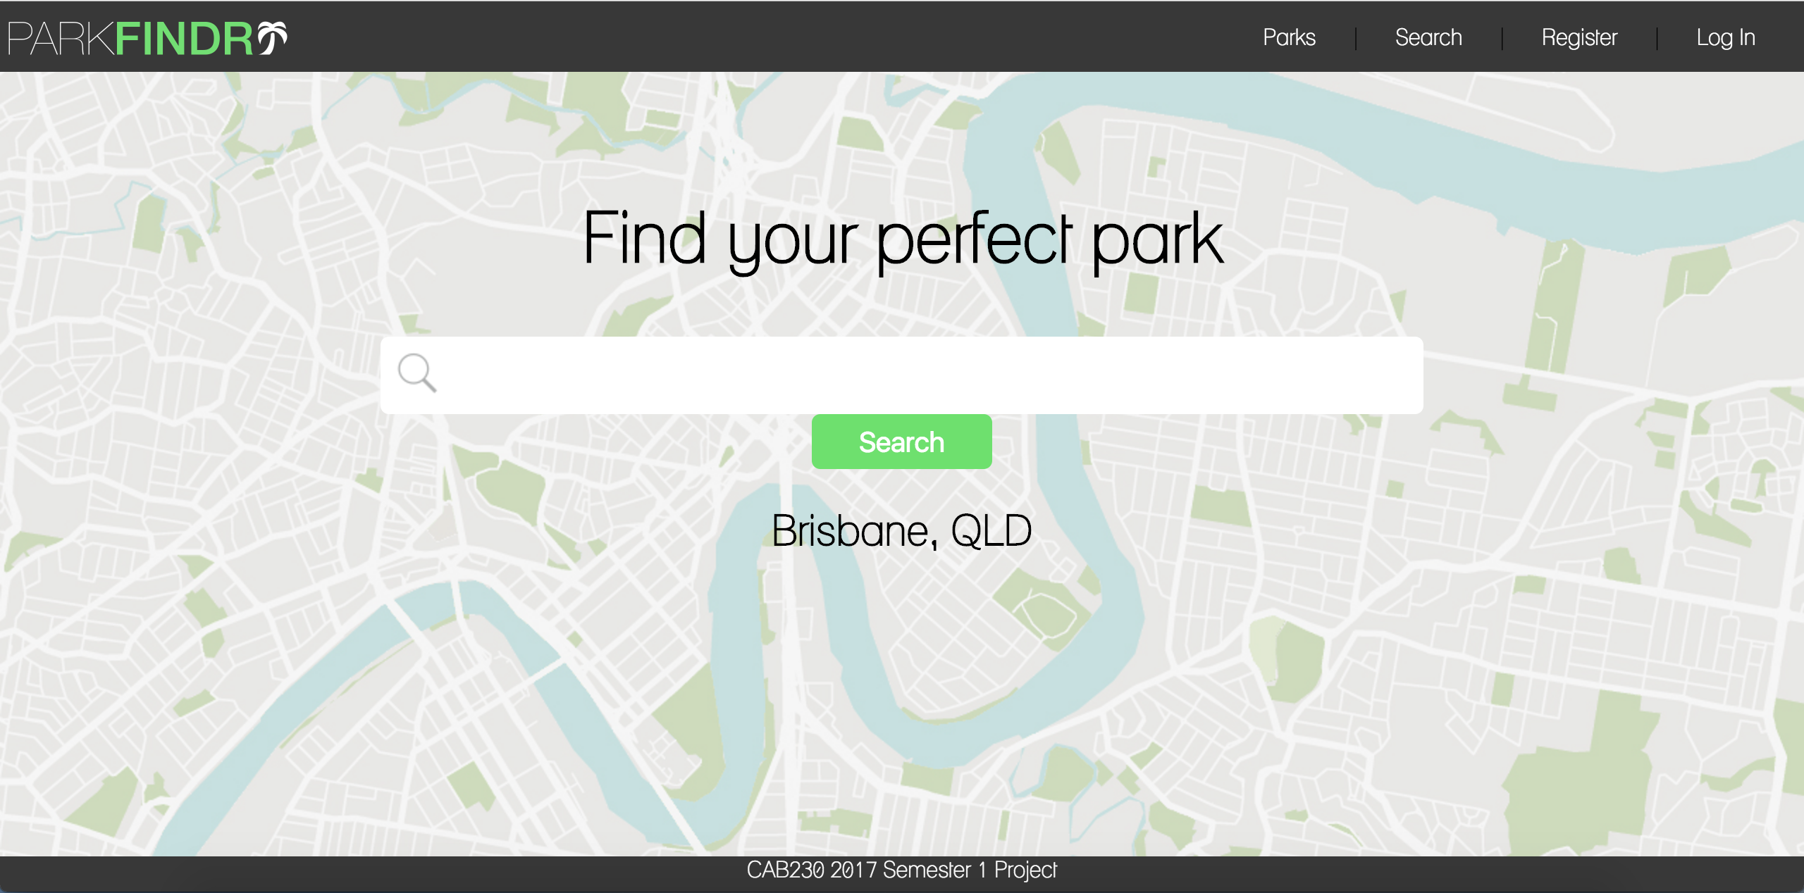

The user can access the homepage with either ‘http://hostname/parkfindr/’ or ‘http://hostname/parkfindr/index.php’. In doing so they will be presented with the home page which can be seen above.

2b. Registering as a new user

Valid input:

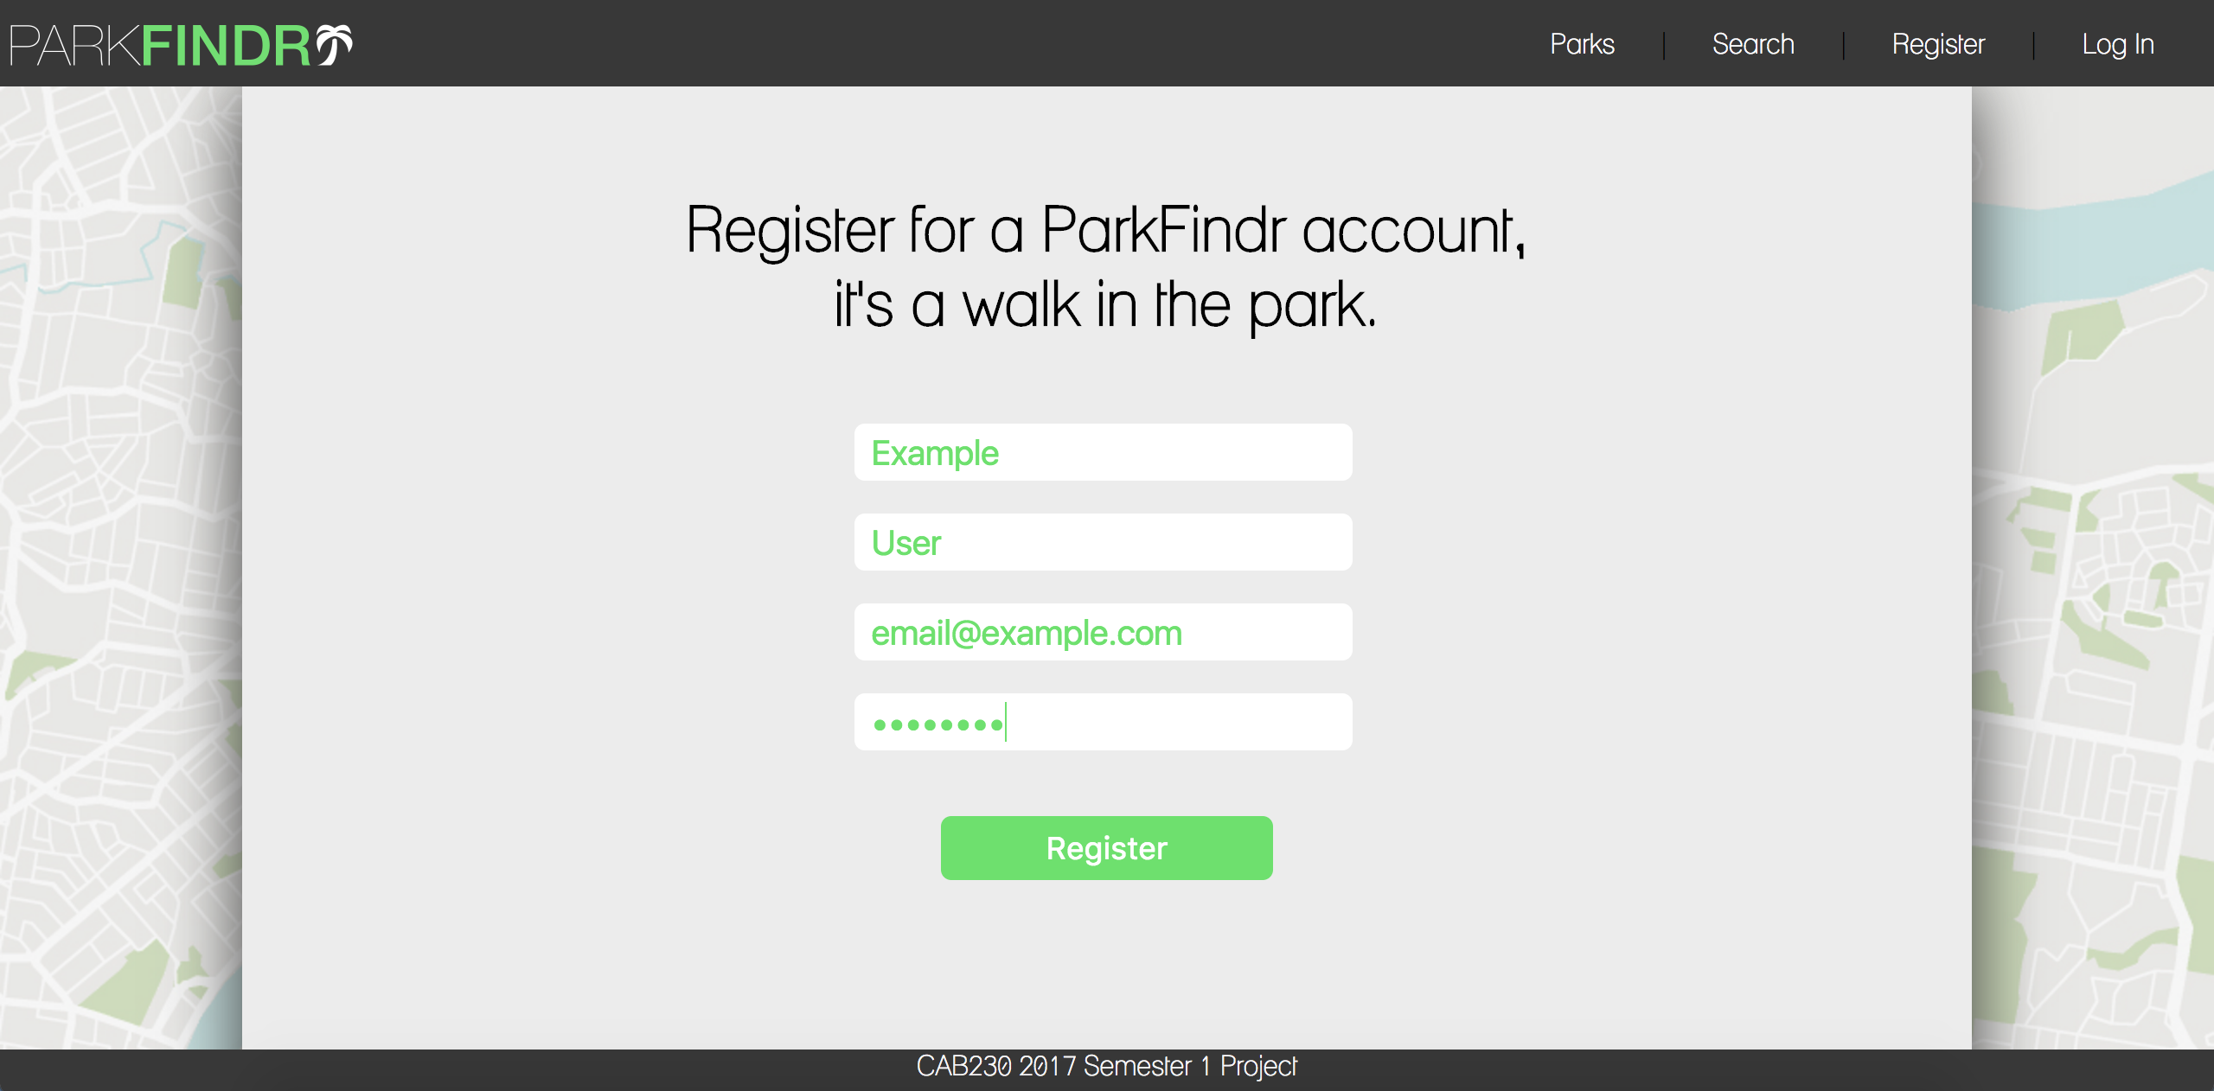

Valid output:

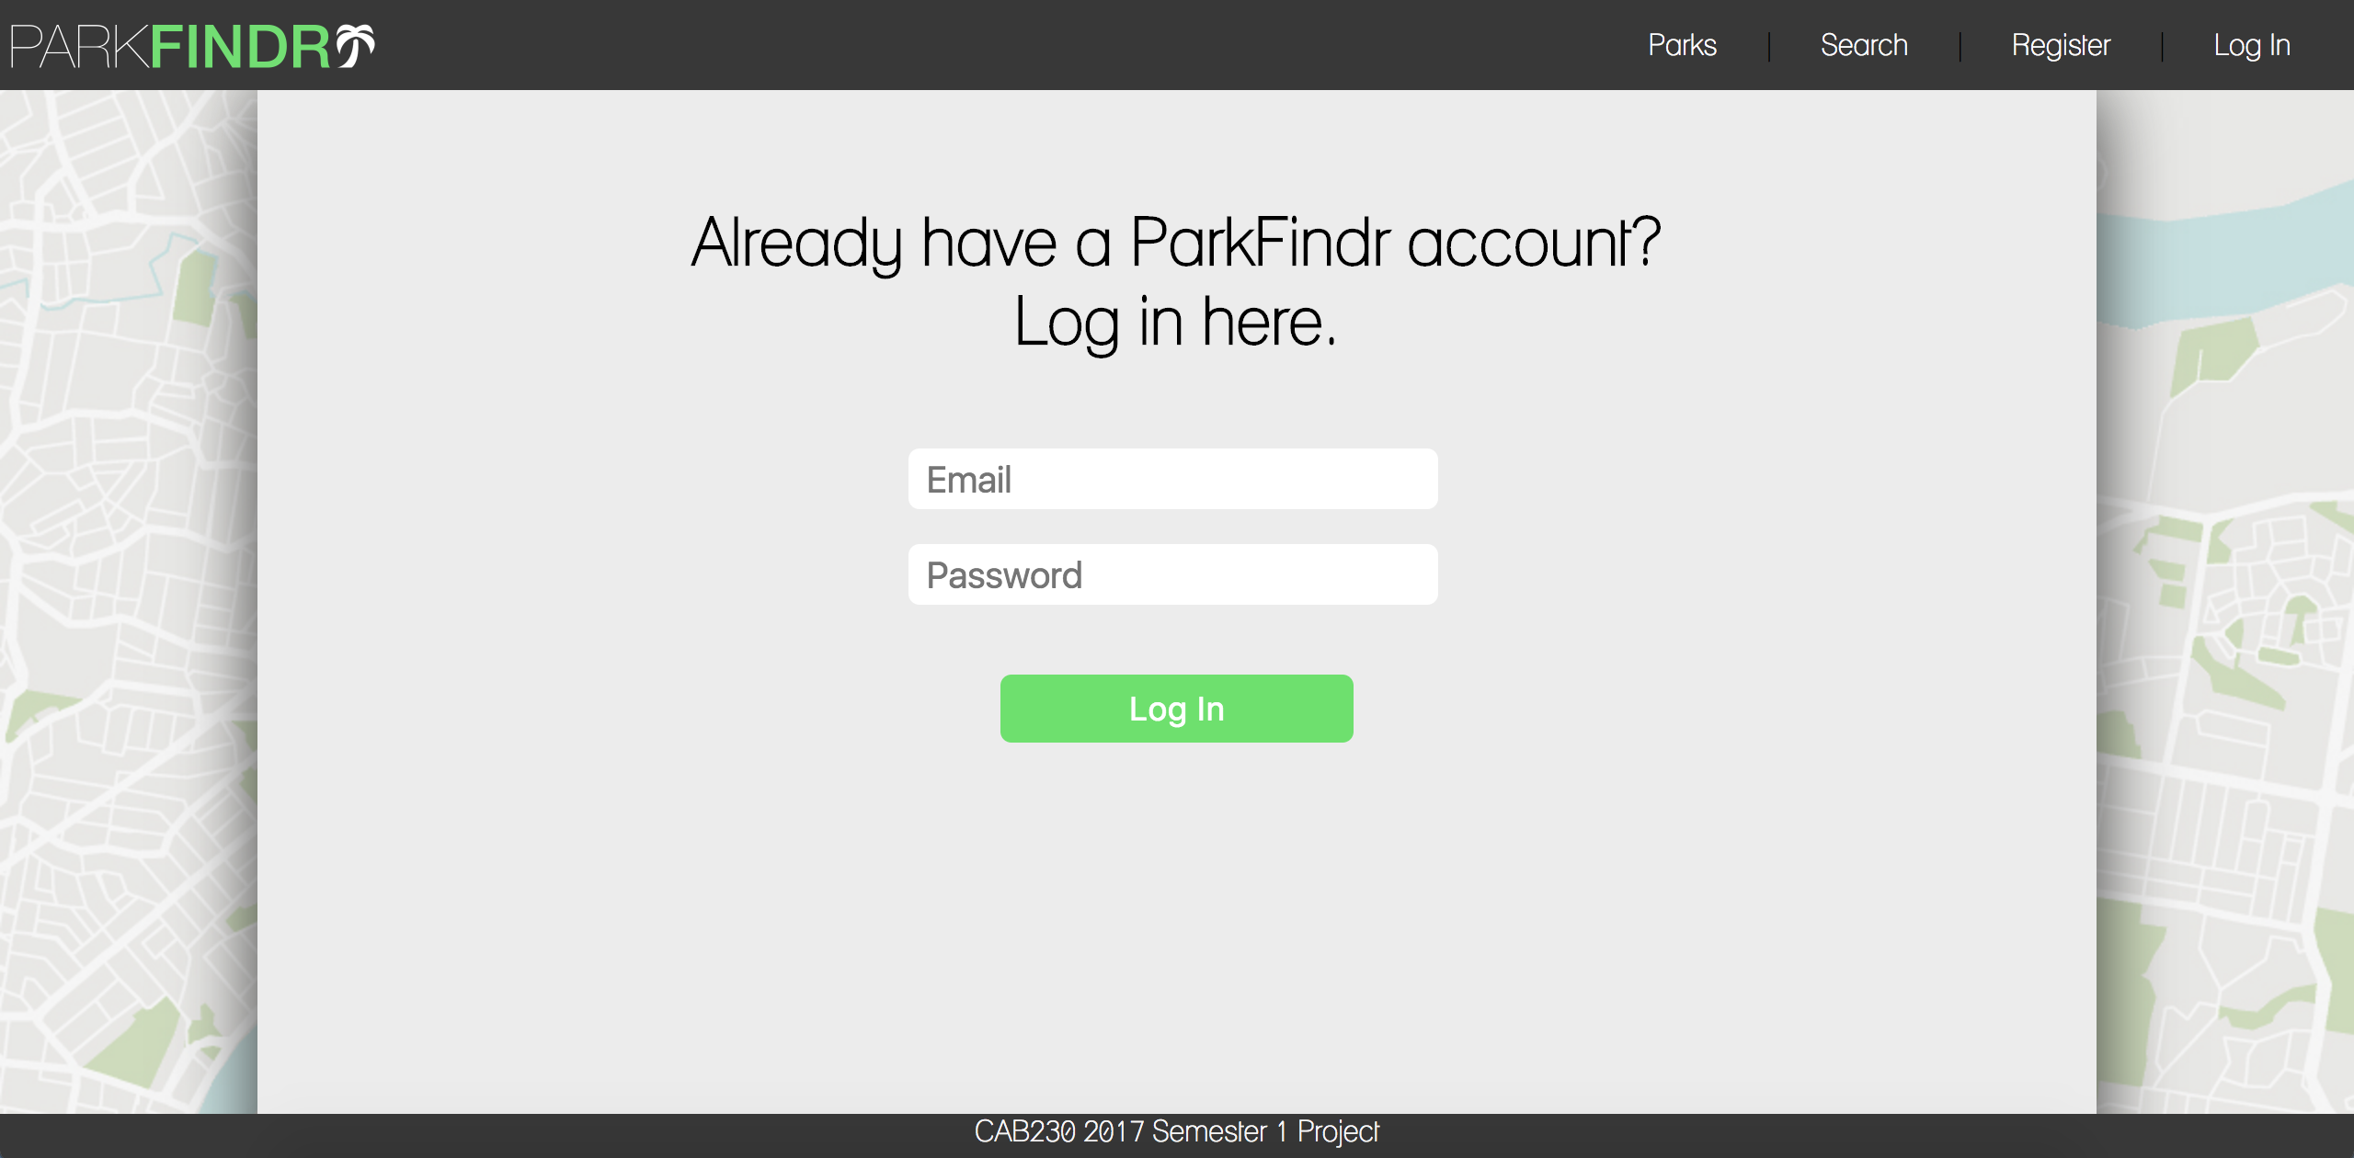

ParkFindr uses both client-side and server-side validation to ensure all fields are valid. When the user enters information into all fields correctly they are then redirected to the Log In page.

Invalid input:

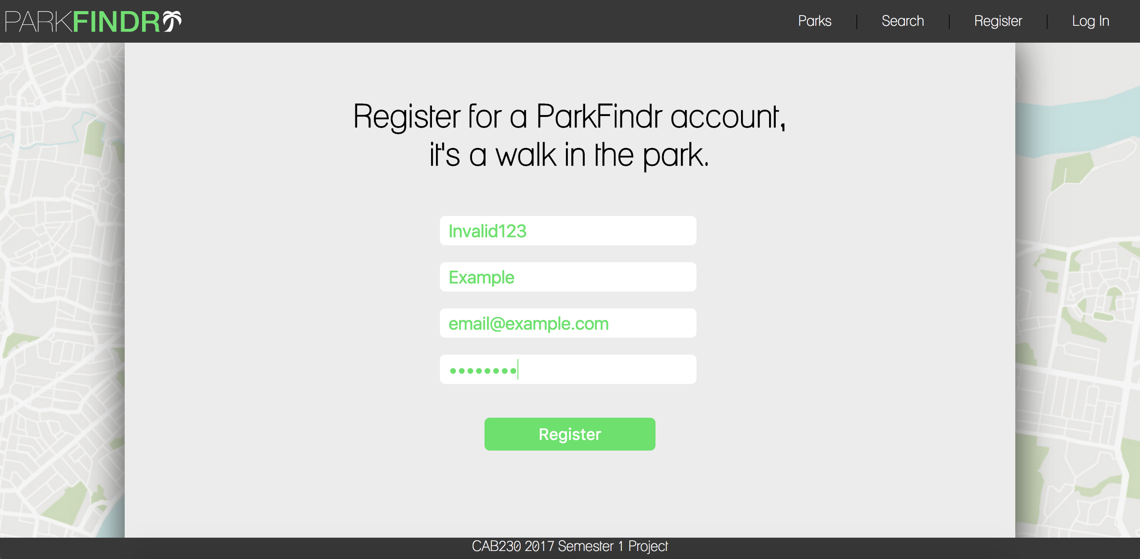

Invalid output:

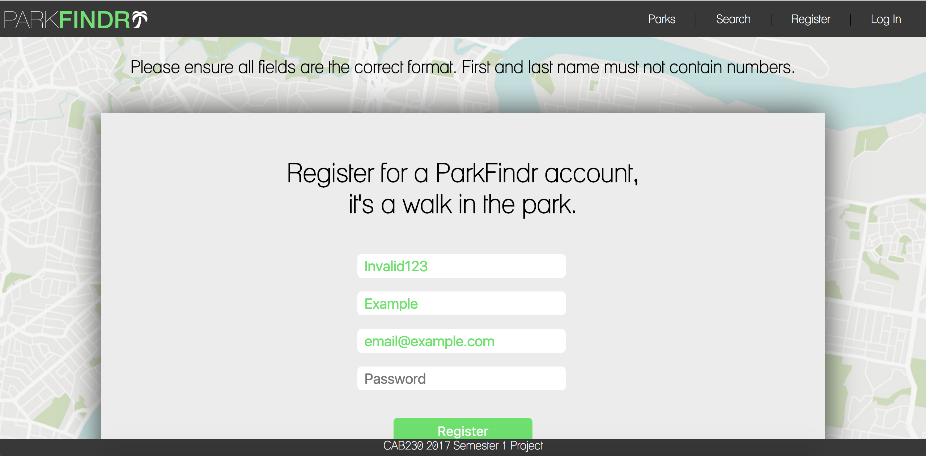

Once the user has entered information into all fields they have passed the client-side validation process. When the register button is clicked the server-side validation process begins, ensuring all fields are the correct format (for example, confirming the first and last name fields do not contain numbers.) If the information submitted does not pass the server-side validation process a message is presented to the user and fields are repopulated.

2c. Logging in as an existing user

Valid input:

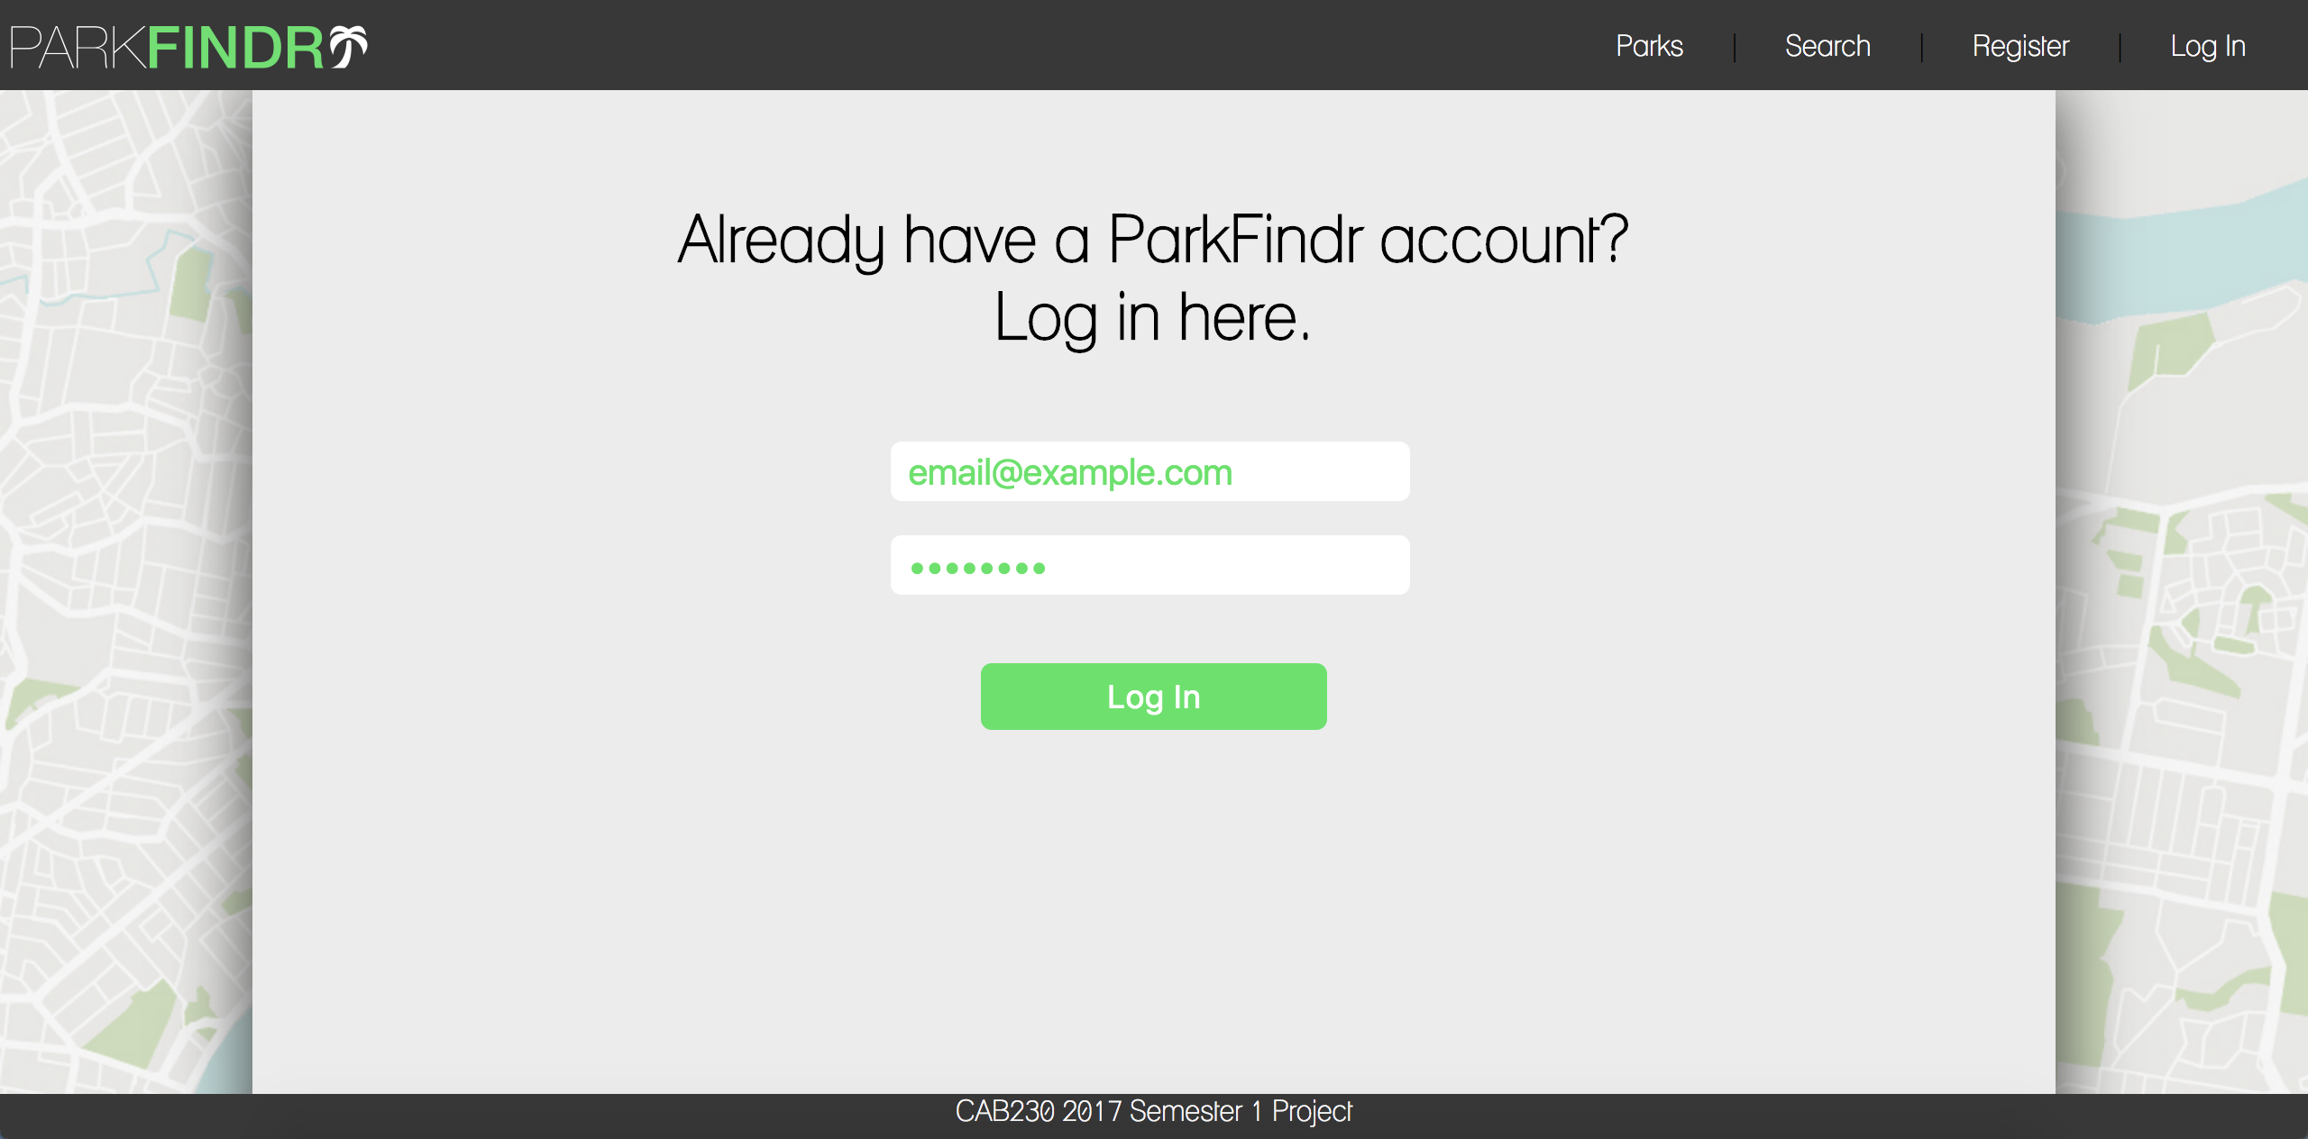

Valid output:

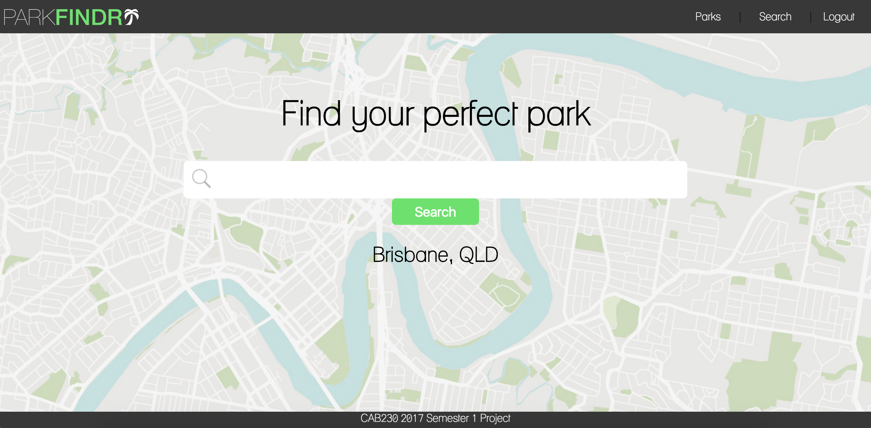

When a user successfully logs in they are redirected to the home page and the navigation bar ‘Register’ and ‘Login’ buttons change to a single ‘Logout’ button.

Invalid input:

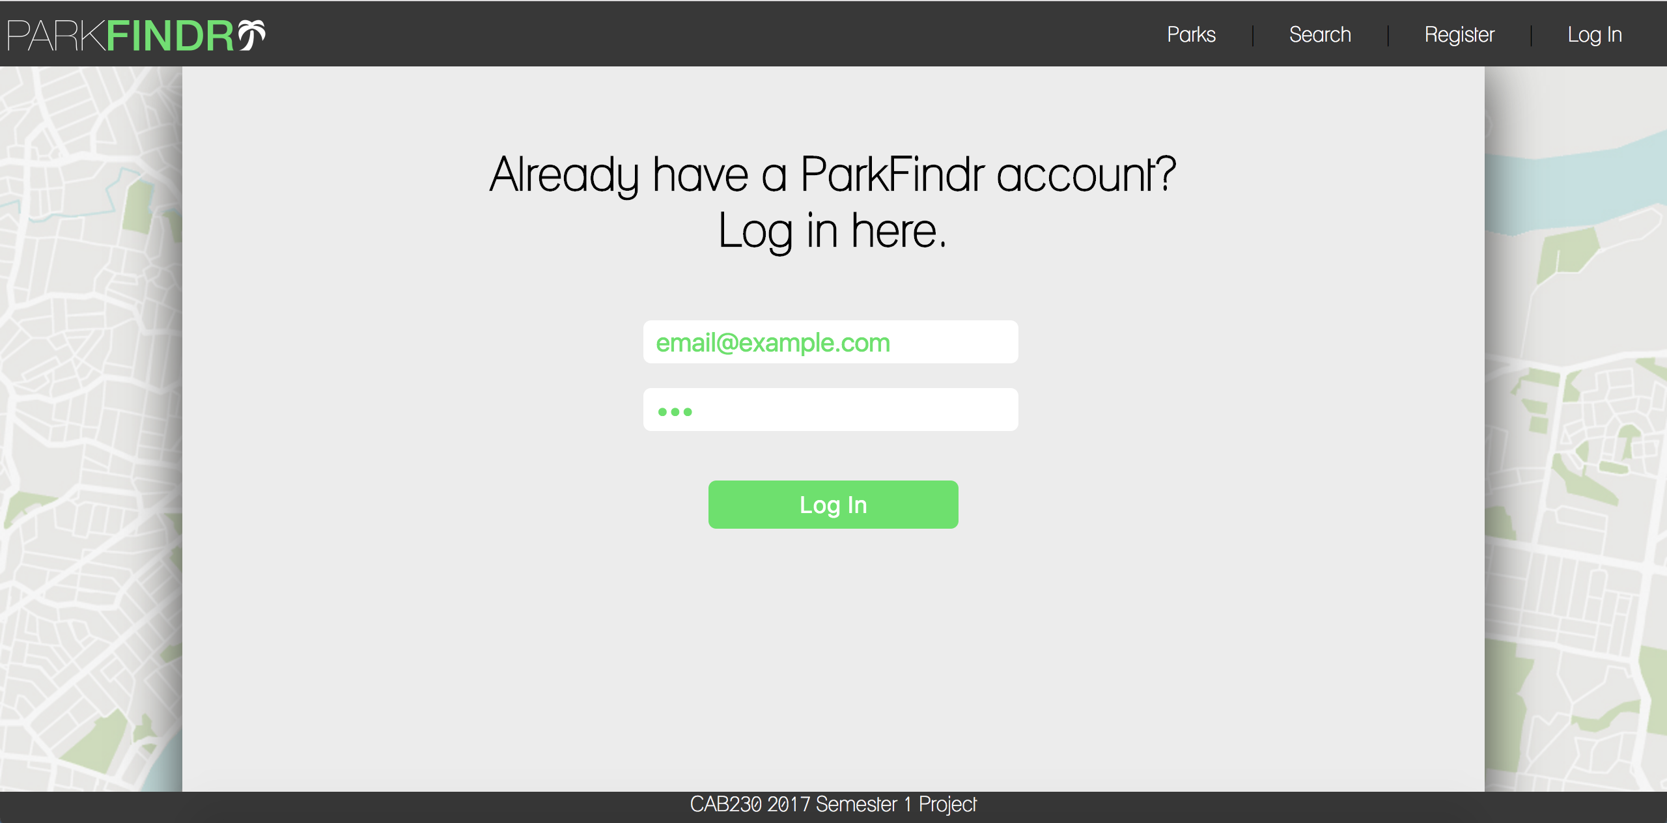

Invalid output:

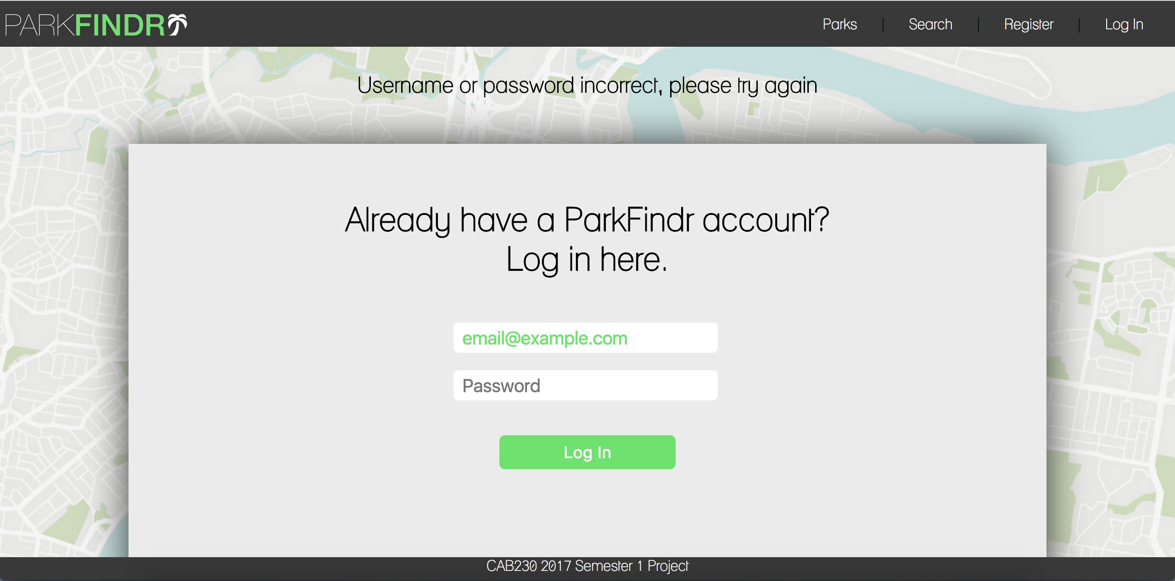

If a user attempts to log in with an incorrect password the above message is presented and the username field is repopulated.

2d. Logging out

Valid input:

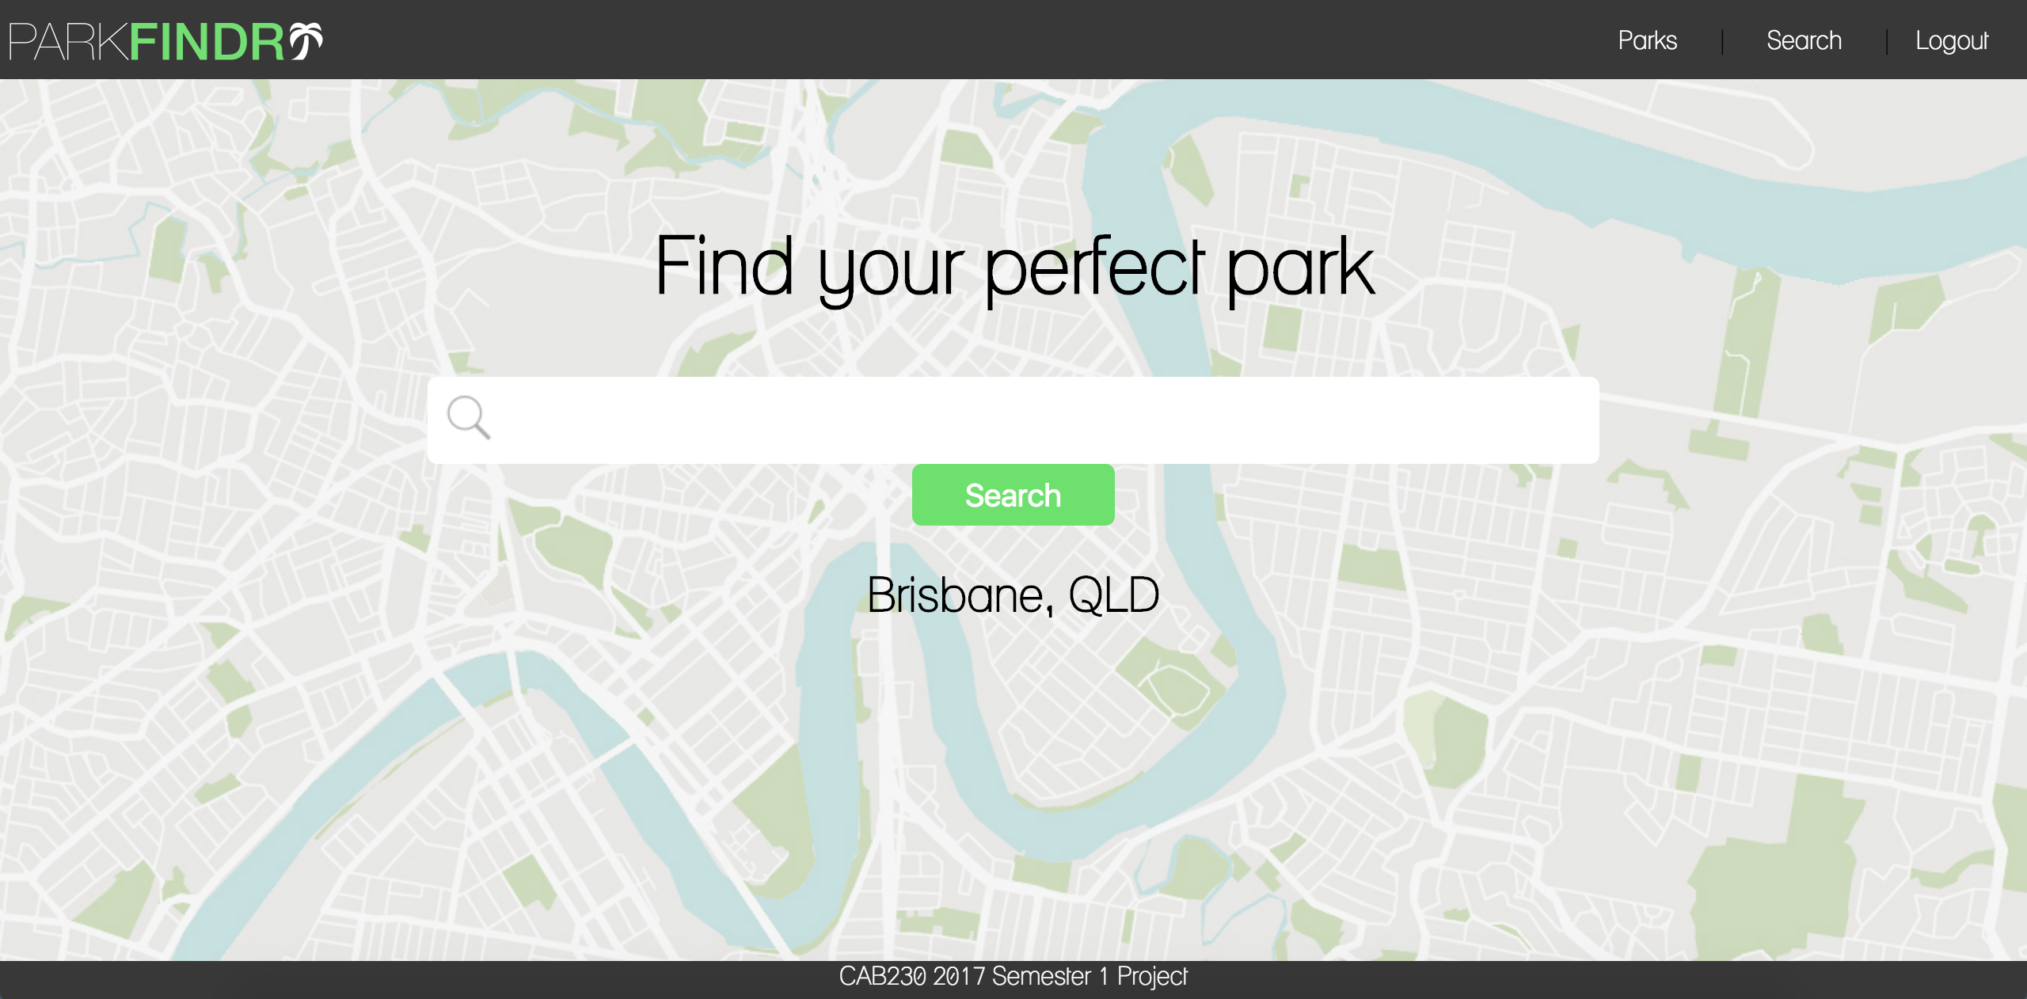

Valid output:

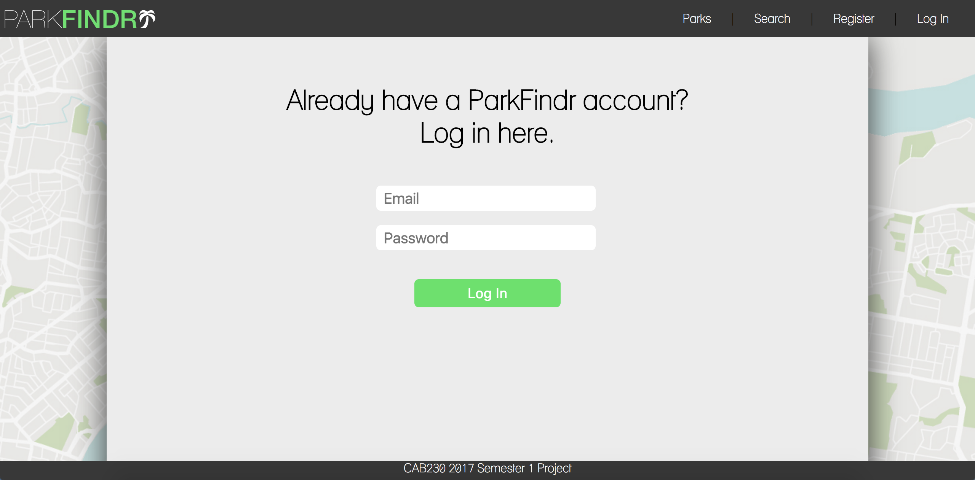

The ‘Logout’ button is visible to the user on every page once they are logged in. When clicked, the user is logged out and redirected to the Login page.

2e. Adding a review

2f. Searching for an item that exists in the database

Valid input:

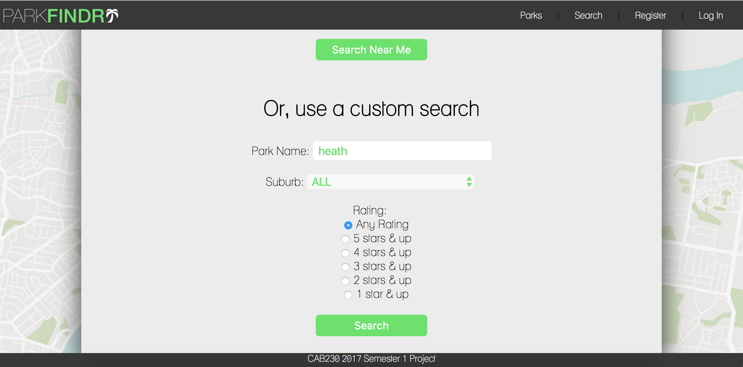

Valid output:

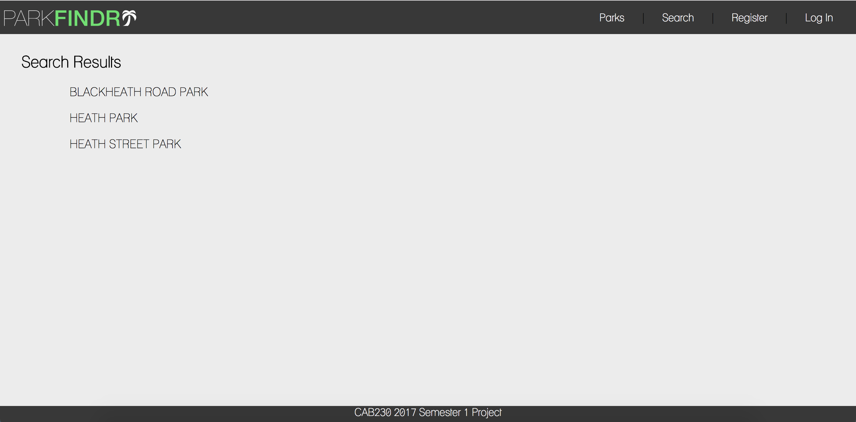

A user can search for parks by name or suburb on the search page. Once the search button is clicked they are then redirected to the results page where all of the results from the search are displayed.

Invalid input:

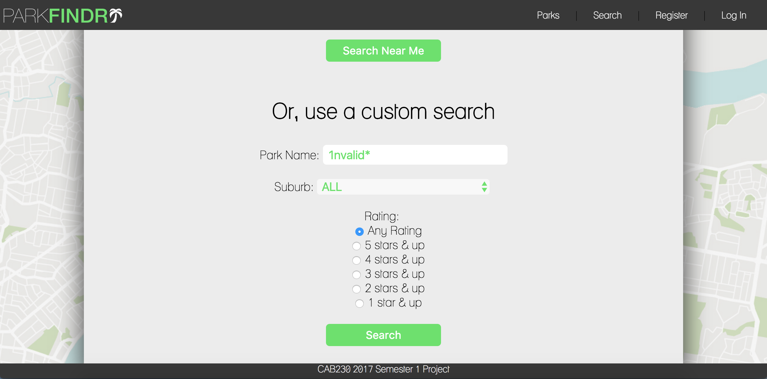

Invalid output:

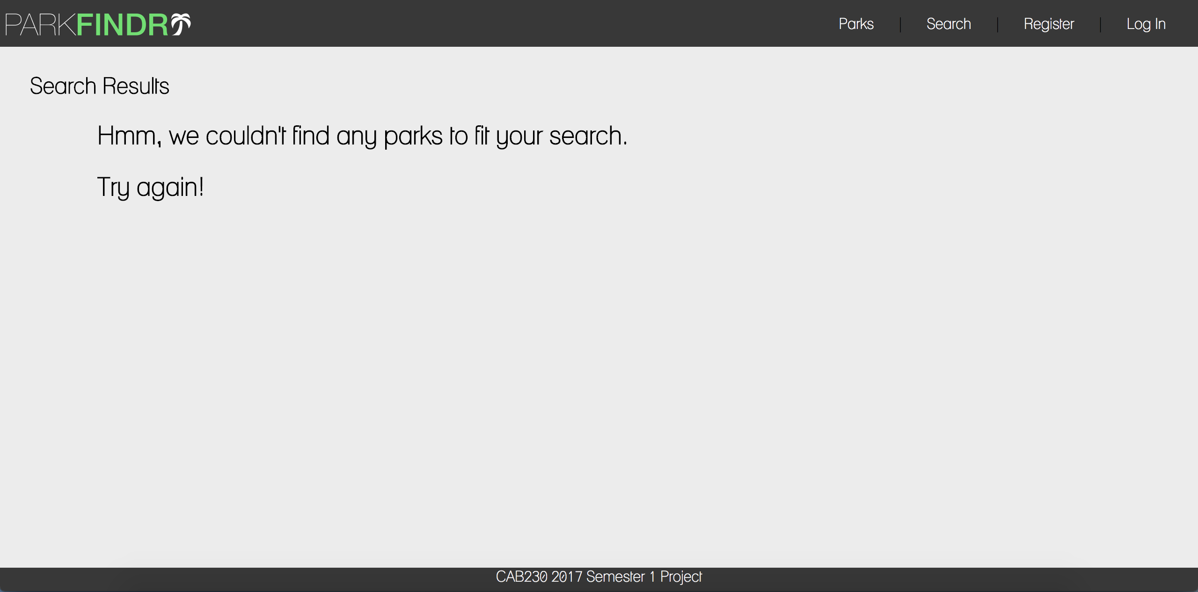

If the user attempts to search using an invalid input, they are redirected to the results page where the above message is displayed.

2g. Searching for an item that does not exist in the database

Valid input:

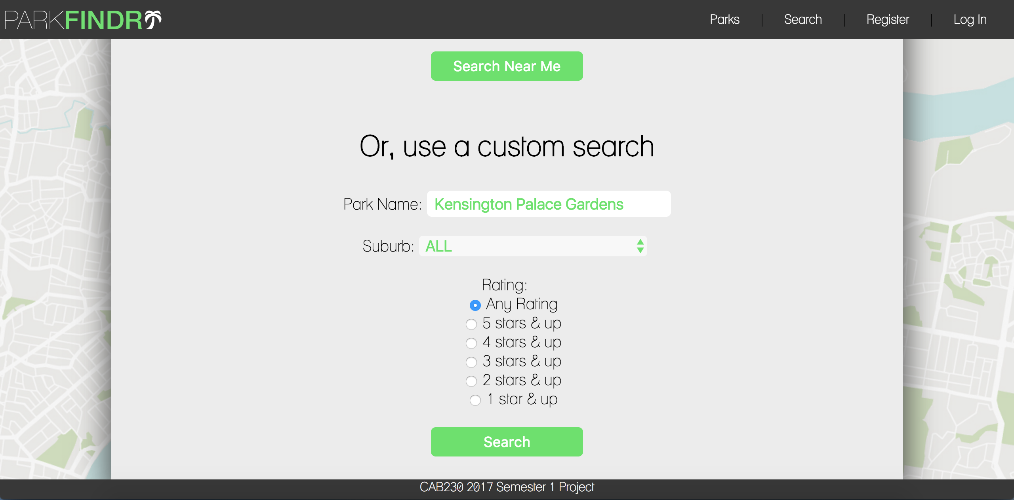

Valid output:

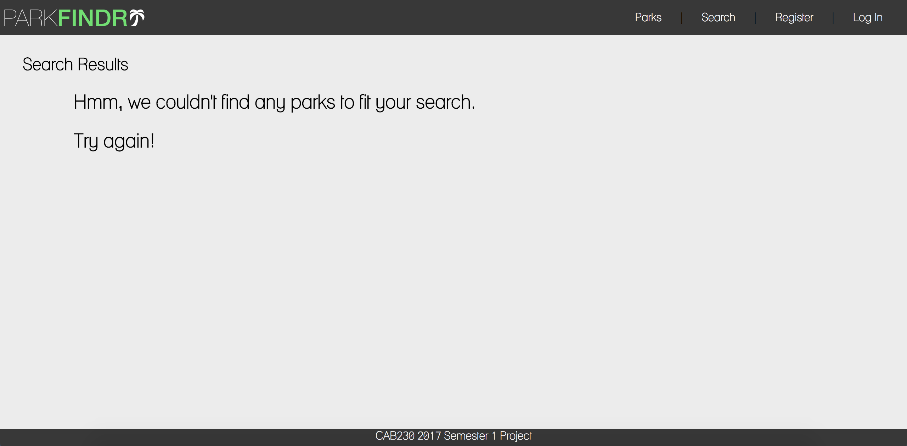

If the user searches for a park that is not in the database, they are redirected to the results page and the above message is displayed.

2h. Accessing an individual item page

Valid input:

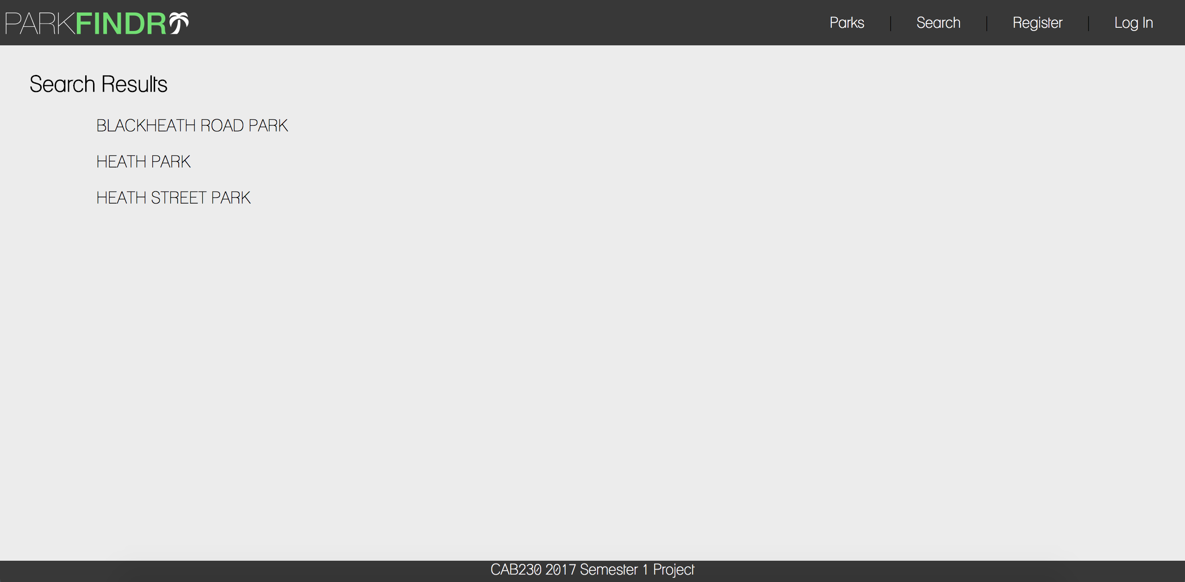

Valid output:

When the user clicks on a park name on the results page, they are redirected to the individual page for that item.

2i. Attempting to use a cross site scripting attack but not being successful

Input:

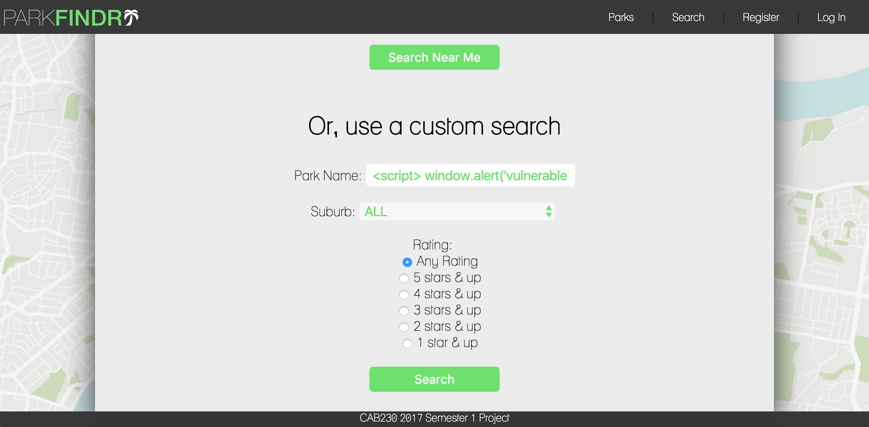

Output:

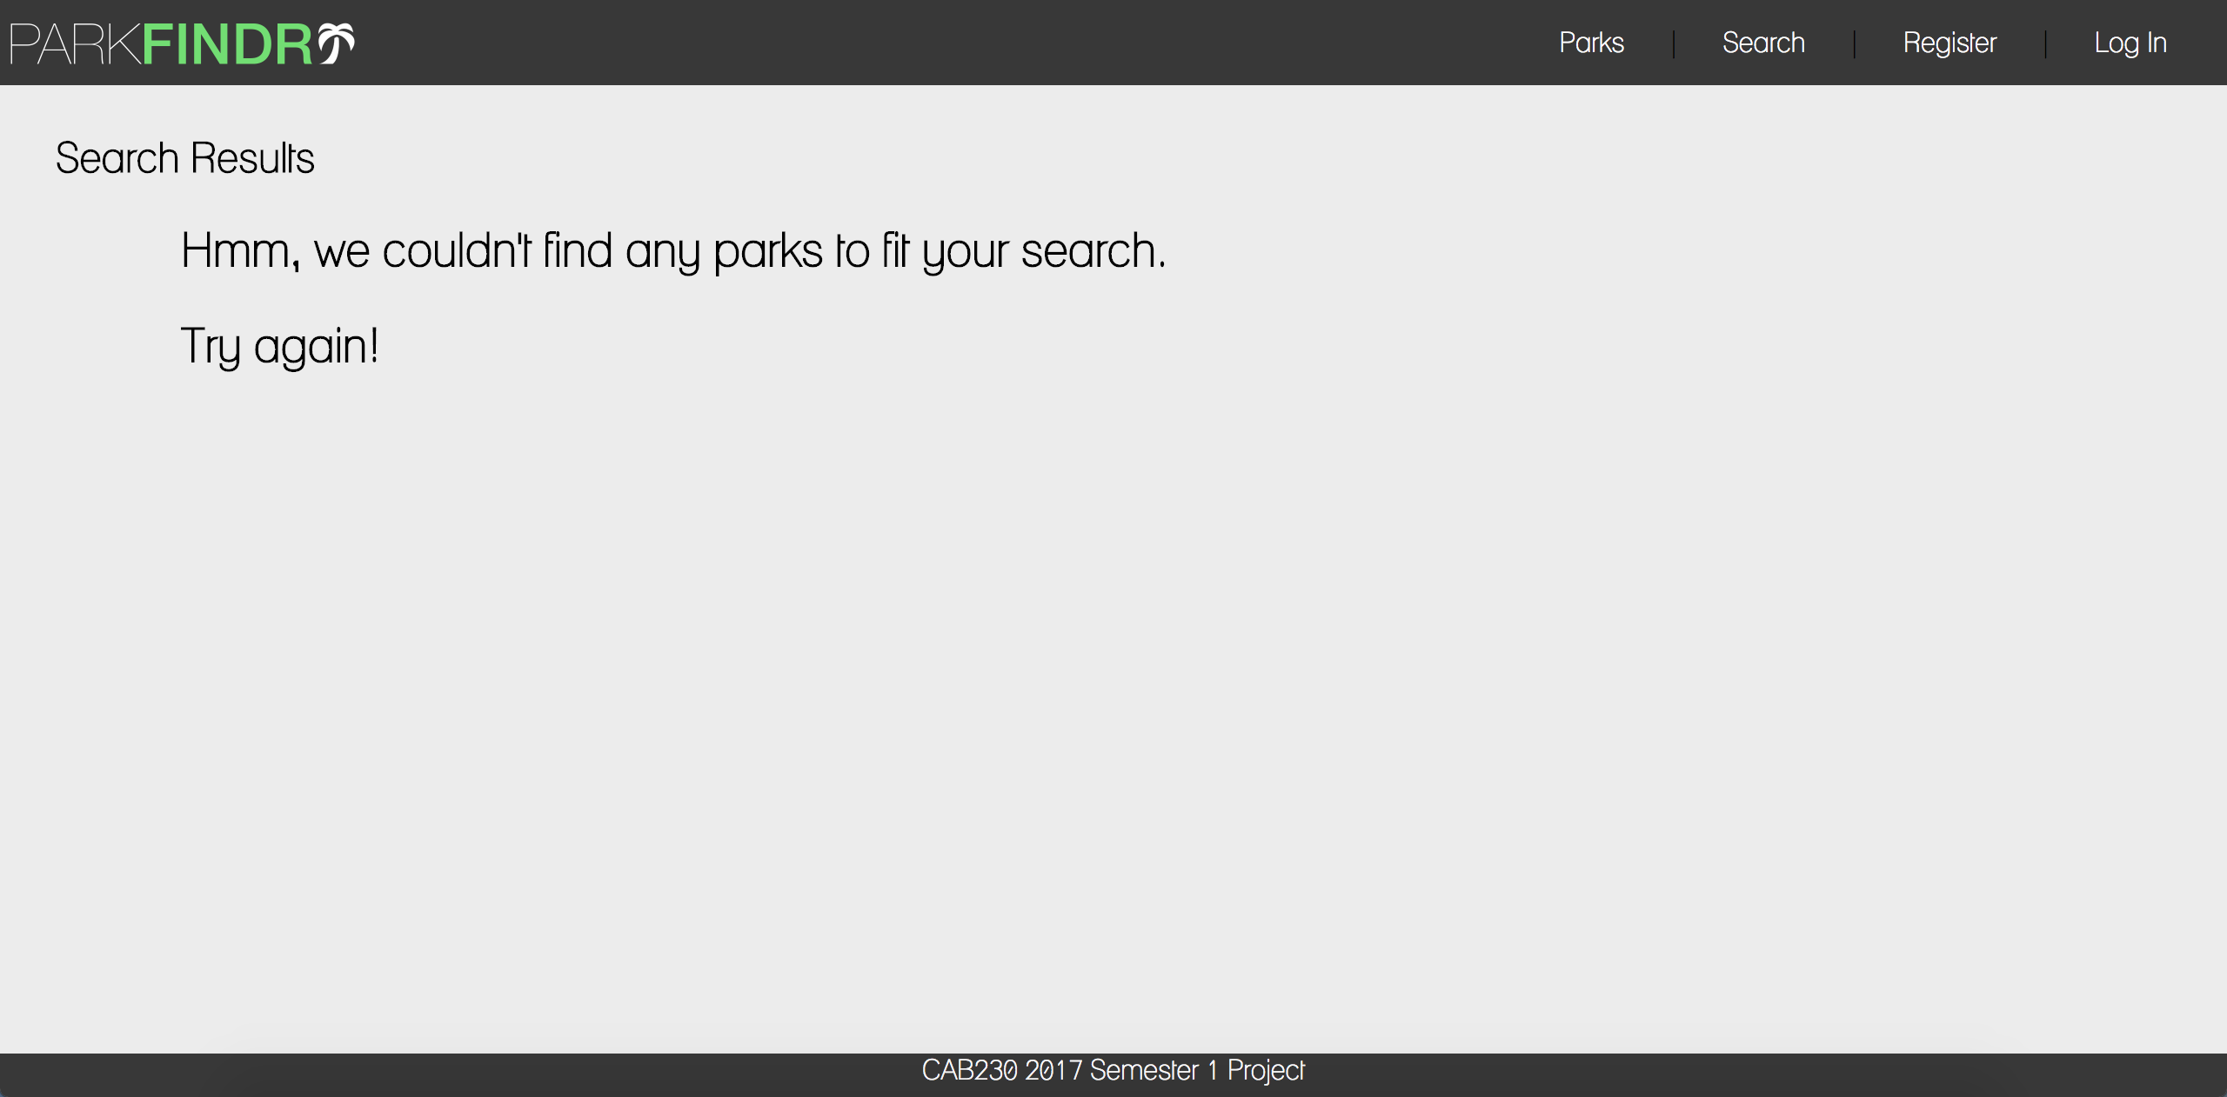

As all input fields throughout the site are validated by both the client and the server, any attempted cross site scripting attacks are unsuccessful.

2j. Attempting to use an SQL injection attack but not being successful

Input:



Output:

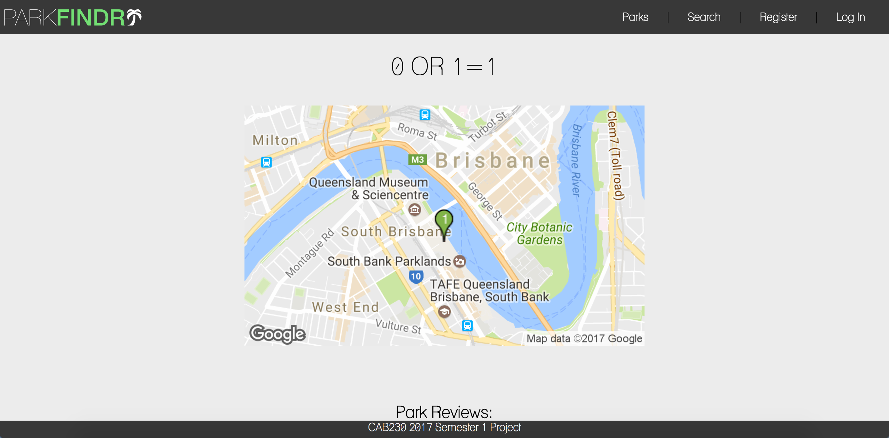

As all SQL statements are prepared before they are submitted, if a user attempts an SQL injection attack they will be unsuccessful. The page is instead displayed as intended with placeholder images in place of any dynamically generated content.

2k. Unregistered user not being able to log in

Input:

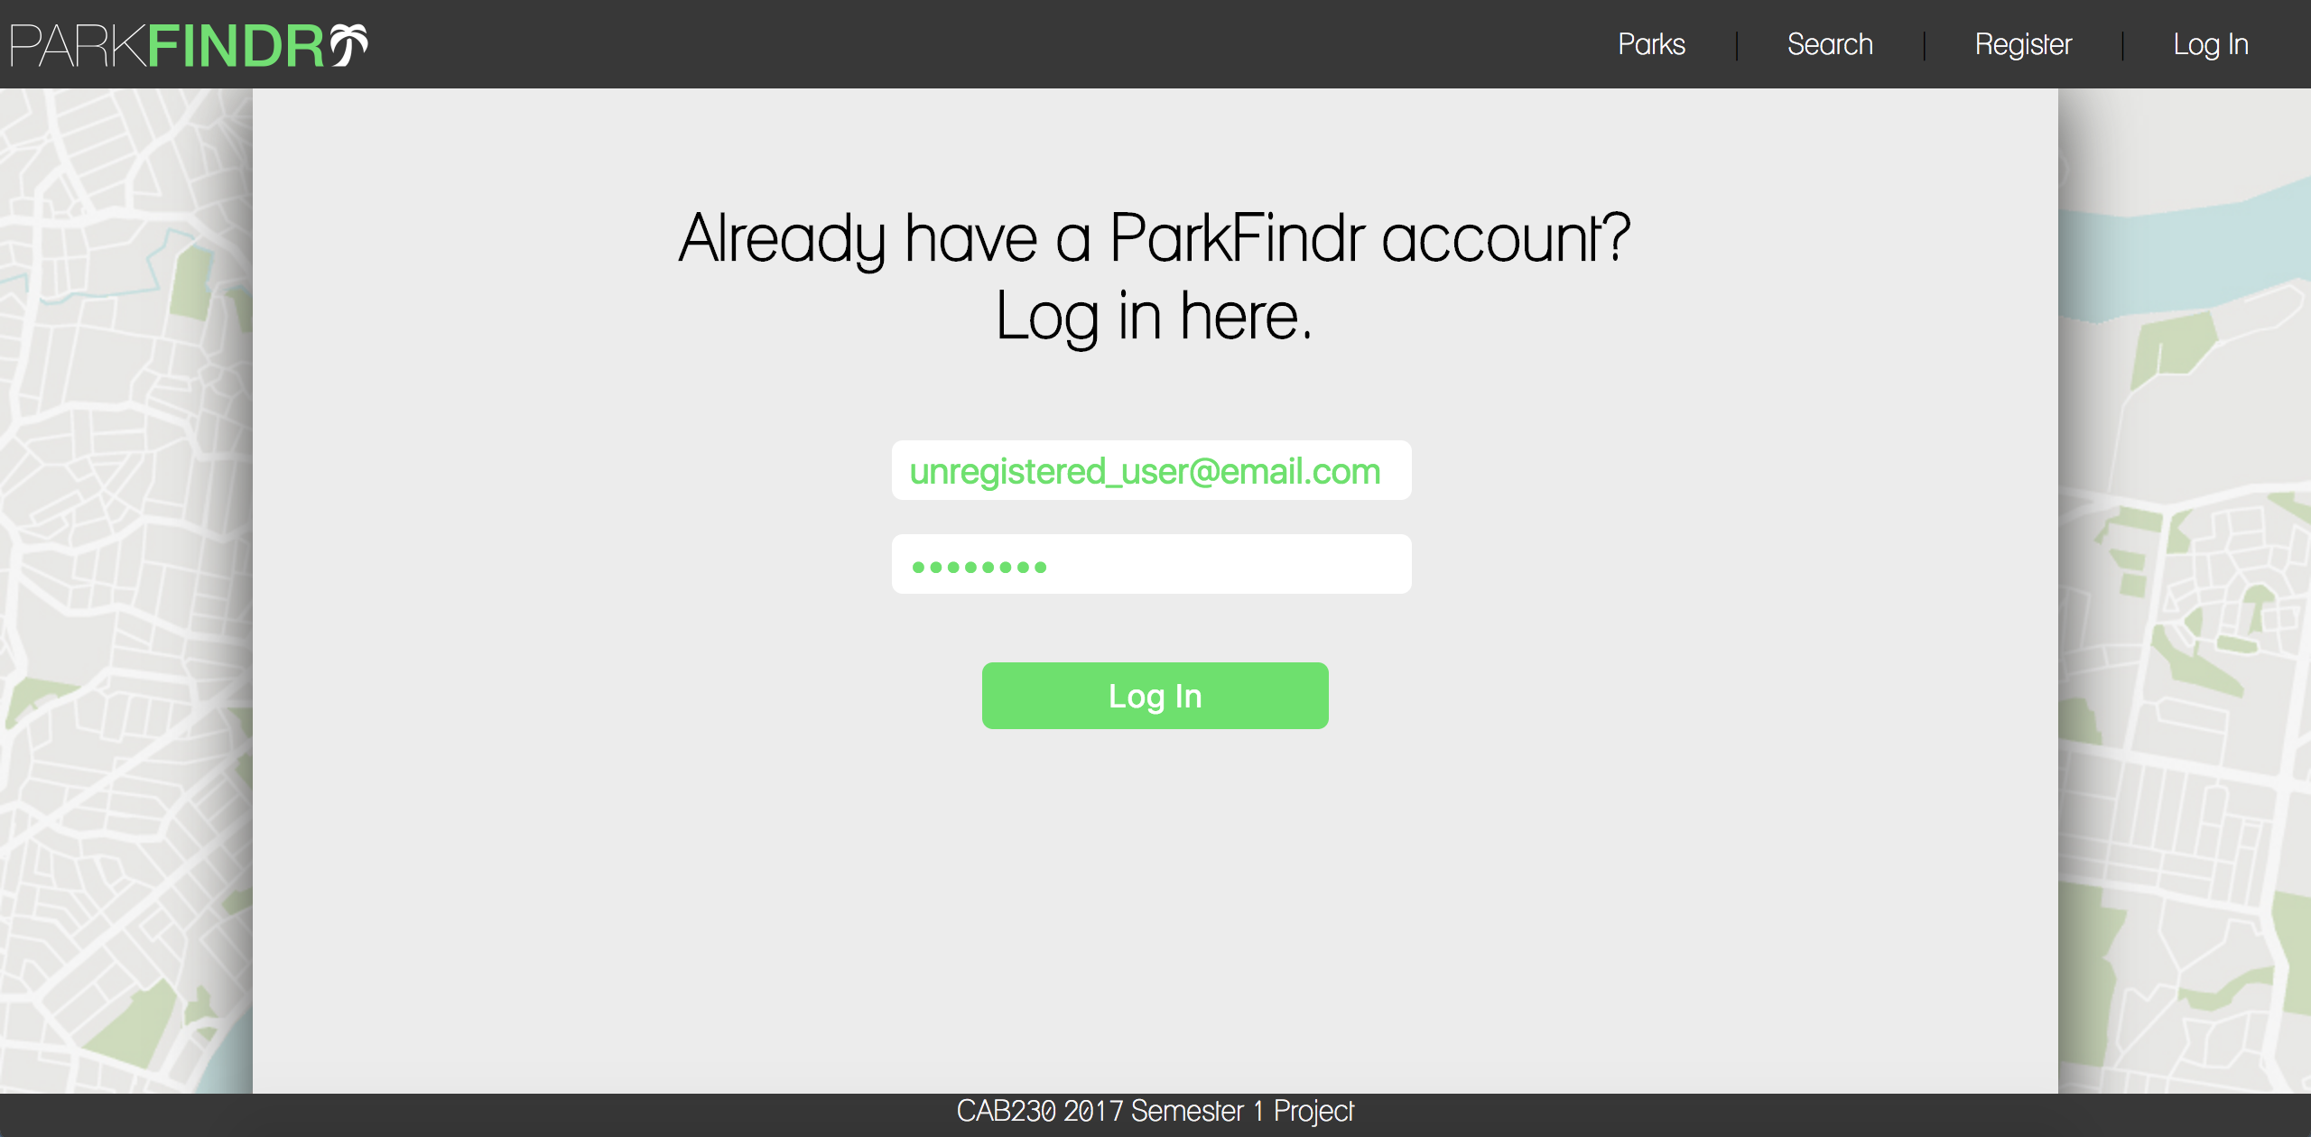

Output:

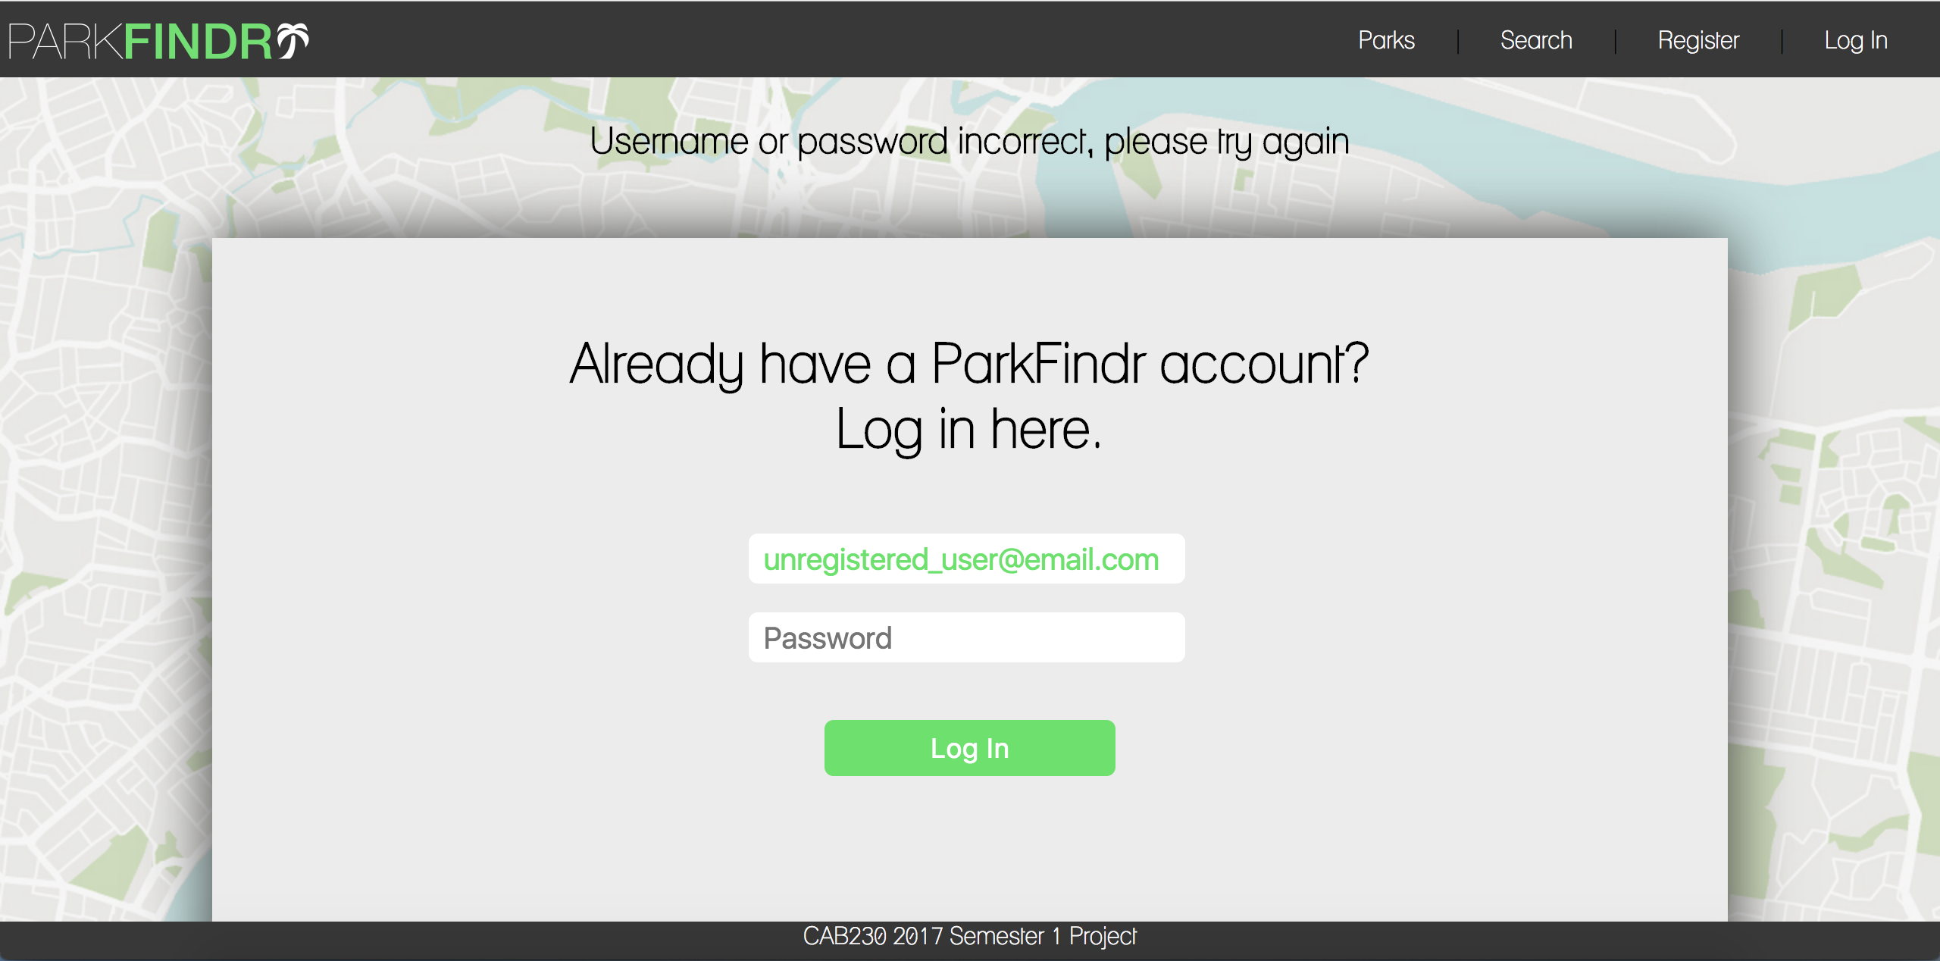

If a user attempts to login to ParkFindr using credentials that have not previously been registered, they are presented with the above message and the email field is repopulated.

2l. Operating gracefully in multiple resolutions

Desktop:



Tablet: Mobile:

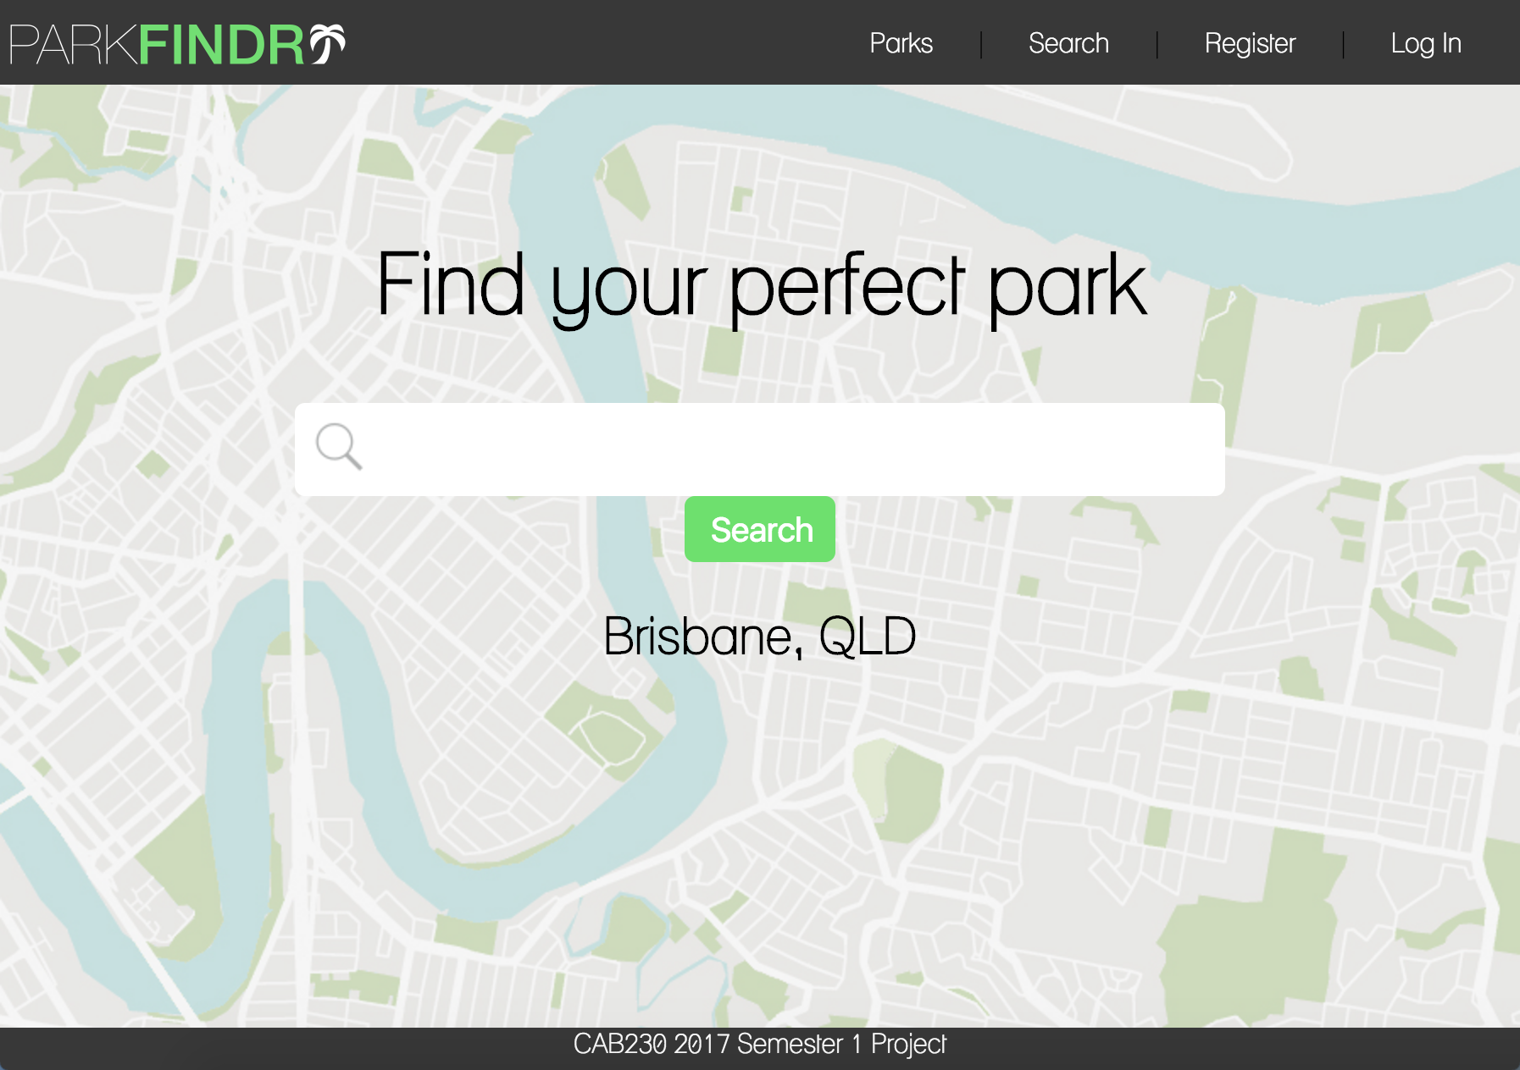 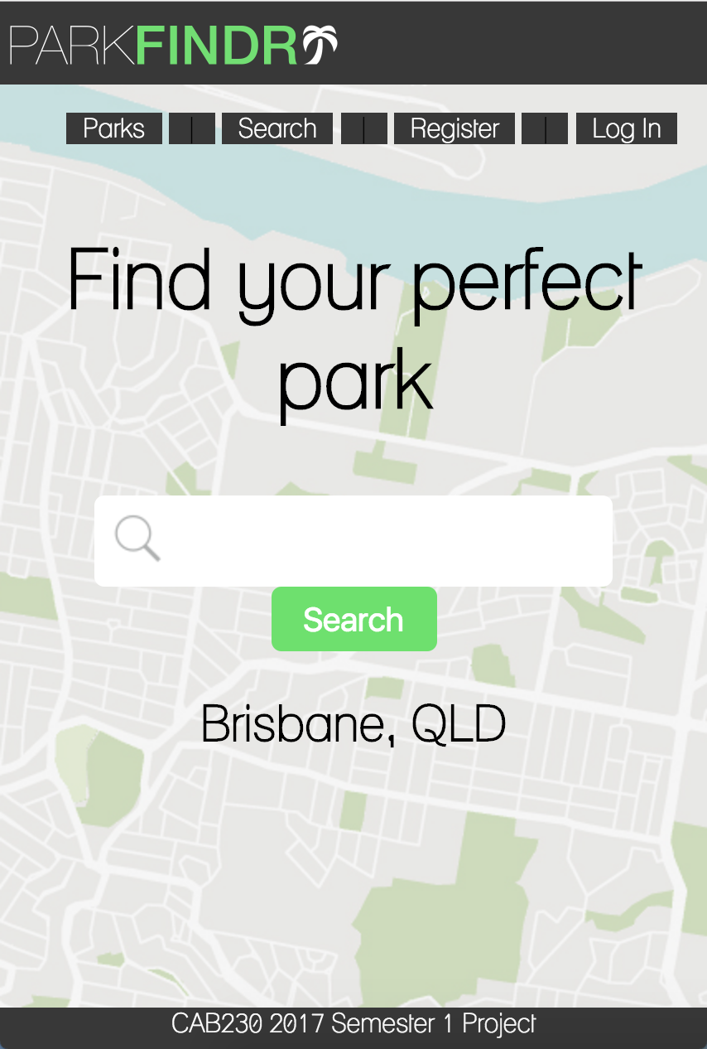

ParkFindr is a dynamic page with the vast majority of elements styled with CSS using percentage-based values instead of fixed-size values. As a result, the site remains usable at a variety of resolutions.

2m. SQL query

Query 1:

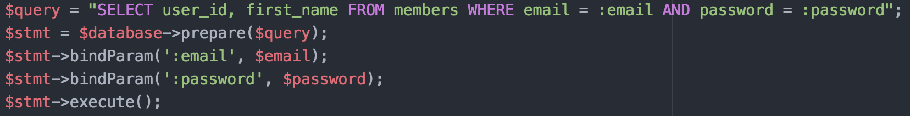

An SQL query located in the ‘includes/login.inc’ file used to retrieve user data for a user when logging in.

Query 2:

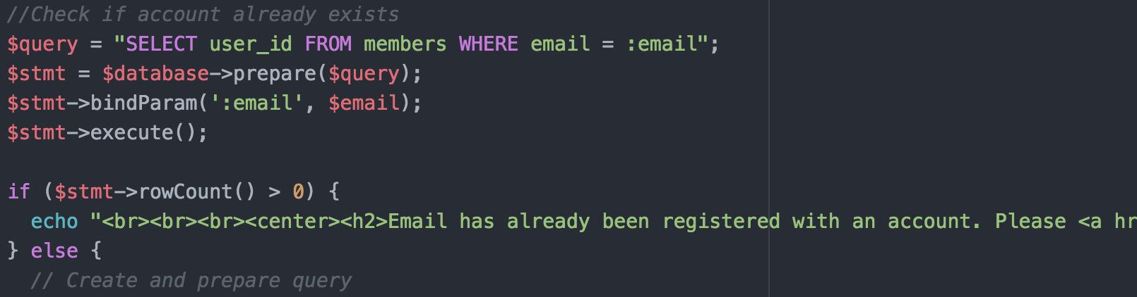

An SQL query located in the ‘includes/register.inc’ file that checks to see if the credentials submitted have already previously been registered. If so, a message is presented to the user.

2n. Results page map

2o. Individual item page map

2p. Valid geographic microdata

2q. Valid microdata

3. Web Design Principles

**User Experience** – ParkFindr focuses on providing users with an easy and pleasing user experience from start to finish. The site includes a number of features that stay true to that of what is standard in the industry such as the Register, Login and Logout buttons being located in the top right corner. The logo in the top left corner will take users back to the home page and the use of both a ‘search’ button and a small magnifying glass icon found in the search bar ensure its purpose is immediately made clear to the user.





**Visual Design** – ParkFindr incorporates a number of methods to ensure the design of the website is engaging and likeable. By using a map faded with a neutral colour pallet for the majority of white space it remains usable and pleasant for users whilst also reflecting the target audience’s location. In addition to this, key features are highlighted in an appealing light green which reflects the true nature of the site, a combination of parks and the environment. As the bulk of our users are local families, a custom font is used throughout ParkFindr to appear enjoyable and light-hearted.



**Page Layout** – ParkFindr operates using a page-based system. Every page on the site is developed using a template we designed to make navigation pages easy and effortless. The header is visible on every page and contains an easy-to-read navigation menu. The content on every page is centred and makes use of dark text over a light, neutral background colour which is further highlighted by the background map. This draws the user’s attention to what matters most on every page without overwhelming them.



**Standards** – In accordance with standards published by the World Wide Web Consortium (W3C), ParkFindr aims to comply with as many as possible. The stylesheet used by our site has been successfully validated and all of the images used throughout ParkFindr meet W3C’s accessibility guidelines, including the use of alternative text.

